**Experiment 04- Deploying application on a web server**

**Learning Objective:** To demonstrate the process of deploying a web application on a web server, ensuring the application is accessible, functional, and secure in a real-world environment.

**Tools:**  Internet Information Services (IIS) Manager. Visual Studio Code, MS Word

**Theory:**

Deploying a web application on a web server involves several key steps to ensure the application is properly configured and accessible to users. The process typically includes preparing the application for deployment, configuring the web server, deploying the application files, setting up necessary permissions, and testing the application to ensure it is running correctly. Understanding how to deploy an application involves knowledge of server configuration, network settings, security protocols, and deployment tools.

Key concepts include:

* **Web Server**: A server that serves web pages to clients (browsers) over the internet.
* **Application Pool**: A mechanism in IIS that isolates web applications for better security and reliability.
* **Site**: A unique URL address and its associated web applications in IIS.
* **Virtual Directory**: A directory that appears to be within the web application's root directory but is physically located elsewhere.
* **Deployment Tools**: Tools like Web Deploy and FTP are used to transfer and configure web application files on the server.

Installation:

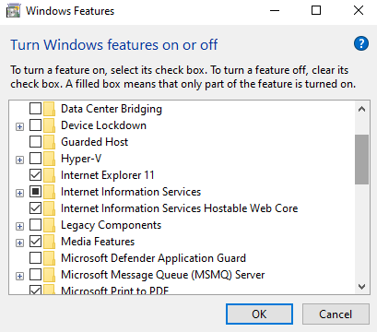

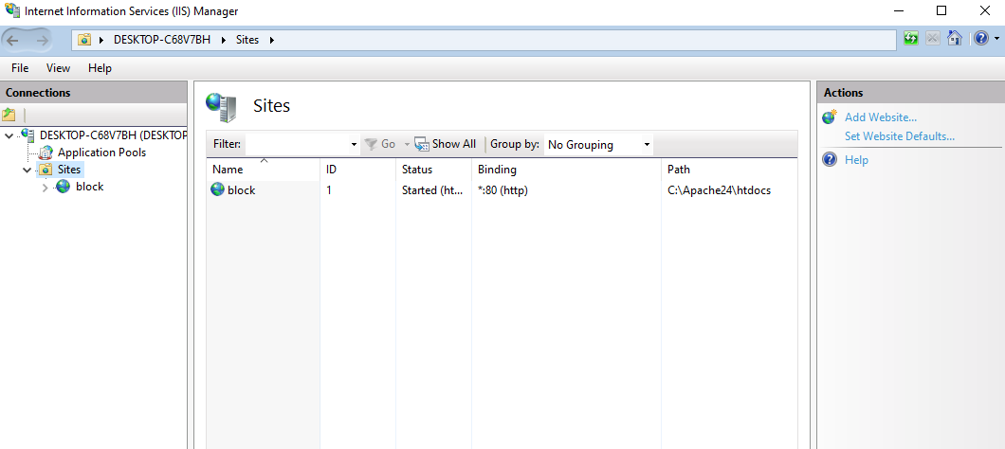

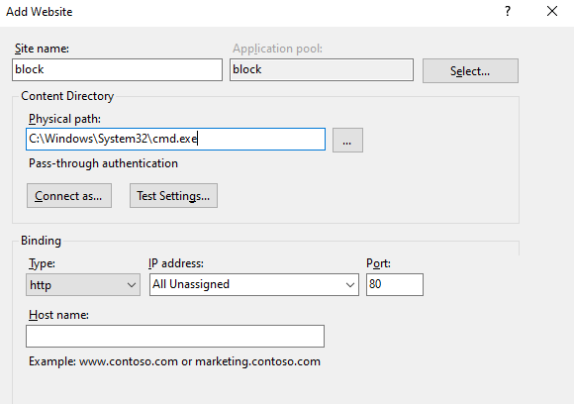

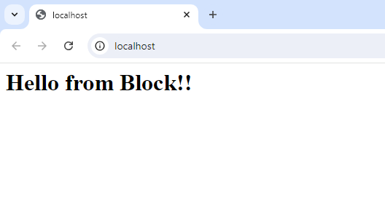

**Learning Outcomes:** The student should have the ability to:

• LO 1: Understand the process and importance of deploying a web application on a server.

• LO 2: Configure a web server for hosting a web application.

• LO 3: Deploy an application using various methods and tools.

**Course Outcomes:** Upon completion of the course, students will be able to:

* Understand and explain the steps involved in deploying a web application on a server.
* Configure web servers such as IIS for optimal application performance and security.
* Use deployment tools effectively to transfer and manage web application files.

**Conclusion:**

**For Faculty Use**

| **Correction Parameters** | **Formative Assessment [40%]** | **Timely completion of Practical [ 40%]** | **Attendance / Learning Attitude [20%]** | **Total** |
| --- | --- | --- | --- | --- |
| **Marks Obtained** |  |  |  |  |